DMI ST JOHN THE BAPTIST UNIVERSITY
MANGOCHI

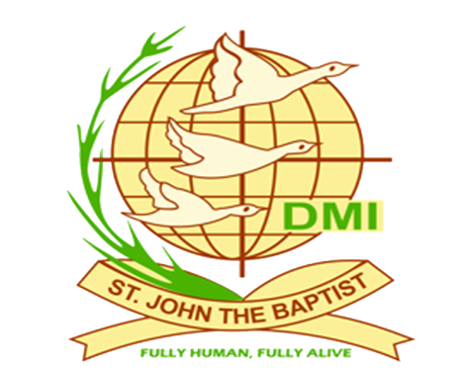

Department of Computer Science and Information Technology

NAME : ANDREW RASHID MOSES
MODULE LECTURER : Mr. CRUSADE CHIWALO
MODULE CODE : 351 CS 2104
MODULE NAME : OPERATING SYSTEM
TITLE : OPERATING SYSTEM SIMULATOR
REGISTRATION NUMBER:
PROGRAM : BSC IN COMPUTER SCIENCE
SEMESTER : III
DUE DATE : 28, MAY 2026

INTRODUCTION
This report explains the development of EduOS, which is a small operating system simulator created as part of the Operating Systems module. The main purpose of the project was to help students understand operating system concepts not only in theory, but also through practical implementation.
During this assignment, we worked with both the C programming language and Python. The C section focused on low-level operating system functions such as process creation, thread handling, race conditions, deadlocks, and inter-process communication. The Python section focused mainly on CPU scheduling algorithms and visual simulations. Mainly this programs where executed in visual studio code by installing the extension of c and python language.
The simulator contains the following major parts; Process management system written in C, Thread pool and synchronization features, Shared memory and pipe communication, Python scheduling simulator, Main controller for integrating all components, GitHub repository for version control

Procedure
Firstly, before starting the coding part, the GitHub repository was first created as required for the assignment. The repository helped to keep track of changes during development.
The project directory was organized into different folders according to their purpose. This helped make the project easier to manage and understand. The gitignore file was also added to prevent unnecessary files such as compiled object files, cache files, and virtual environments from being uploaded to GitHub which was to our advantage to prevent the unnecessary files.
The multiple commits made during development was so that progress could be tracked properly. Some commits were related to process management, while others focused on thread management or scheduling algorithms and many more areas.
Using GitHub also helped to understand the importance of version control in software development. Whenever something broke in the program, I could go back and check previous commits.
The Process Control Block was one of the most important parts of the project. Every process created in the simulator contains information stored inside a PCB structure and the simulator uses several processes states similar to real operating systems. When a process changes state, the simulator prints logs showing the transition. The assignment required several system-call-like functions to be implemented.
The edu fork () call, this function creates a child process from a parent process. The child receives a new PID and is inserted into the PCB table. The edu exec (), this function replaces the current process image with another process. The edu wait (), This function allows a parent process to wait until its child finishes execution. The edu exit (), This function terminates a process and releases allocated resources. The edu ups (), This function displays all active processes in the simulator.
The simulator writes PCB data into a JSON file called pcb_snapshot. json. This file acts as a bridge between the C part and the Python scheduler.
Instead of creating new threads repeatedly, the simulator uses a thread pool containing worker threads. The thread pool uses POSIX pthread, Mutex locks, Condition variables and task queues. Worker threads sleep when there are no tasks and wake up when new tasks arrive.

Two threading models were demonstrated in the project which are the many to one and one to one model where in first, multiple user threads map to one kernel thread and the second model, every user thread maps directly to a kernel thread respectively. This model allows true parallel execution on multi-core systems. deadlock and race condition and mutexes were demonstrated to illustrate how processes execute in this state and how to apply mitigate this situation in order to avoid them.

Then inter-process communication was illustrated through shared memory where the simulator uses POSIX shared memory for communication between the process and pipes method was also illustrated where the parents write the information and the child reads the data.
Processing scheduling was also implemented in which showed method of first come first served, shortest job first, priority scheduling, Round Robin and then calculated the processes tie of different execution as shown in the document containing the outcomes.

Lastly, the main controller folder contains the file code that links all the rest of the folder file of c and python and runs it all at once which performs time launches of the C binary, generates process data Monitors PCB states, runs scheduling algorithms and produces final reports and visualization as shown in the document containing the output. The communication between the C and Python sections happens through JSON files.
One important lesson from this assignment was understanding the difference between low-level and high-level programming.
In C language Memory must be managed carefully, data structures must be implemented carefully and Errors can cause segmentation faults.
In Python development is faster, libraries simplify many tasks and data structures are easier to use since python is flexible and working with both languages together helped me appreciate how real systems are built using multiple layers.
C helped me understand how things work internally, while Python helped me focus on simulations and analysis.

Conclusion
EduOS was one of the most challenging but also one of the most educational assignments I have completed. The project improved my understanding of Process management, thread scheduling, Synchronization, deadlocks, inter-process communication mechanisms and CPU scheduling algorithms
Building the simulator from scratch gave me practical experience that cannot easily be gained from theory alone. The project also improved my debugging skills, GitHub usage, and confidence in combining multiple programming languages within one system.Overall, the EduOS project successfully demonstrated important operating system concepts and provided valuable hands-on experience.

References
- Silberschatz, A., Galvin, P. B., & Gagne, G. Operating System Concepts. Wiley.
- Course Lecture Notes – Operating Systems Module.
- Operating University Basics, Cambridge University, accessed through google.com. Retrieved from cl.cam.ac.uk

